A framework for evidencing teaching in academic promotion

Purpose

Making Evidence Count is a framework to assist universities to clarify evidence of teaching achievement at different academic promotion levels.
It reframes teaching and evidence of teaching using three different perspectives (Figure 1)
- Scope of activity
- Sphere of influence
- Source of evidence.
While academic promotion processes in Australia and the United Kingdom are, in principle, committed to recognising and valuing teaching activities, what constitutes evidence of teaching activity has in general not been well understood by promotion committees. Nor has there been clarity on how to evaluate evidence in teaching-related applications.
Making Evidence Count:
Figure 1:
Promoting teaching – three perspectives on teaching & evidence of teaching
- demonstrates how evidence of teaching can be presented and evaluated through peer review and measurable indicators
- takes into account the changing nature of teaching in today’s complex higher education sector
- is adaptable and acknowledges the different missions of universities
- offers a flexible framework to support universities to develop their own guides for applicants and promotion committees for teaching and promotion.

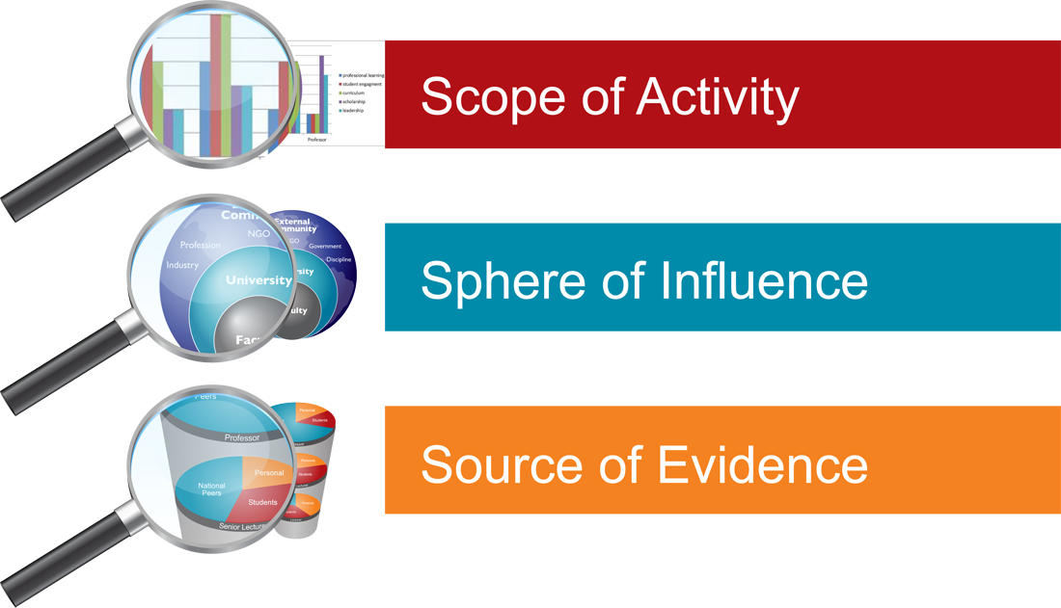

Developed for the Higher Education Academy (UK) by two Australian universities (Tasmania and Wollongong) and two British universities (Leicester and Newcastle), 2013 with advice from 15 universities through an International Advisory Group.

Understanding teaching

Making Evidence Count also includes a series of linked discussions, each focusing on an aspect of teaching in higher education. It is clear that different interpretations of the nature of teaching can impact on a university’s approach to teaching evidence in promotion applications. Does mentoring new teaching staff count under ‘teaching’ or under another category such as leadership or governance? Are teaching-related publications classified as part of teaching or as part of research, or does this depend on the type of publication? Where such understandings are tacit rather than explicit and vary even within a single academic unit, confusion may be common.

Why define teaching?
How teaching is defined and which aspects of academic work count as teaching can inform the process of evaluating teaching for promotion. Promotion committees need guidelines and criteria to evaluate teaching in an equivalent way to research.
In a rapidly changing university sector, it becomes even more important to define teaching. There is a pressing need to establish some common language around extremely complex and continually changing practice. Teaching in modern universities is increasingly likely to take a “non-traditional” approach, drawing on a diverse range of skills and developing new expertise. Given this, it is necessary to provide some definition of teaching that might be used for:
- Setting expectations in professional teaching standards
- Defining teaching activities for diverse teaching roles (eg sessional, research-intensive, clinical supervision, deans, educational developers)
- Acknowledging the impact of student diversity and choice of learning environment, and the subsequent impact on teaching
- Quality assurance of all aspects of learning environments (eg programs, subjects, laboratory and clinical work, computer-based learning, fieldwork, work placements, resources, support, feedback)
- Developing theories about teaching and sharing practice and resources, and
- Communicating the work of academics to the wider community, including governments, students, employers and potential academics.
All of these have an impact on a university’s success and are relevant in promotion committee discussions. For an individual academic, continuing discussions on the scope of teaching activity are important to clarify the demands of the role, expectations and career directions.

Other resources
Although Making Evidence Count is a stand-alone resource, the project recommends universities situate development of their own evidence guides within the context of a complete review of promotion policies, processes and perceptions for recognition of teaching. To assist with reviews, several resources are available from the Promoting Teaching web site www.promotingteaching.com:
- Good Practice Benchmarks – a set of 18 benchmarks for reviewing recognition of teaching in academic promotion.
- Benchmarking Guide – provides processes and templates for reviewing your university against the 18 benchmarks, including processes for cross-institutional review.

Three perspectives on teaching evidence
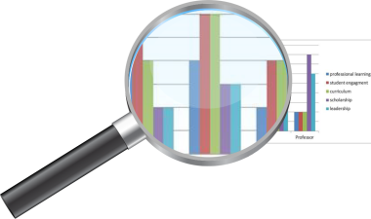 | Perspective 1: Scope of activity  Teaching is not only student interaction, therefore promotion committees will need to see evidence across a range of teaching activities. Five activities are suggested on page 4, describing diverse teaching activities and roles: Professional Learning; Student Engagement; Curriculum Development; Research & Scholarship; and Leadership & Collaboration.

Perspective 2: Sphere of influence
Similarly, university teachers have influence beyond their students. They are active across entire programs, across the university and, often, engage strongly with external accreditation bodies, professions, industry or government. Promotion committees will search for evidence of teaching leadership and impact in different spheres of influence from local to national and international, as depicted on page 6.

Perspective 3: Source of evidence
Since teaching activity has a broader scope than interaction with students, evidence will be viewed from a range of sources. Three sources are identified on page 8, each with changing importance and volume of evidence at different promotion levels: Personal; Students; and Peers.
What is teaching?
Promoting Teaching’s review of literature (see References on p 18) and review of frameworks used by the benchmarking partners led to a categorisation of university teaching across five activities: professional learning; student engagement; curriculum development; scholarship; and leadership.
Many of these activities will be influenced by:
- an understanding of learning and the learning environment, including the principles of adult learning
- the academic’s philosophy of teaching, and
- the nature of the subject.
The overall picture must also be considered, including:
- equity
- how the specific subject and the approaches to teaching align with institutional values and goals, and
- the broader context of tertiary education.
These understandings are applicable regardless of whether the teaching is in the context of large scale core subjects, service subjects, smaller specialist topics, postgraduate coursework or research higher degree supervision.
A list of key references on these and other aspects of teaching is provided on p 18.

Perspective 1: Scope of activity

It is important that the scope of teaching-related activity is defined for promotion. This will vary from university to university, with some having broader definitions of activities such as academic leadership and public engagement.
The Promoting Teaching project’s review found that any consideration of teaching at university level should include the following five activities:

Professional learning | Participating in teaching-related workshops and seminars; obtaining (or furthering) teaching qualifications
Student engagement | Includes face-to-face teaching in classrooms; teaching by distance and online; providing support and feedback; research supervision
Curriculum development | Resources for courses; curriculum review, design and innovation; evaluation and alignment to standards
Research & scholarship | Presentations, grants and publications
Leadership & collaboration | Mentorship, governance, peer review, course accreditation.
“Just” teaching – or a complex, multifaceted profession?
Shulman (1987) considered the work of secondary school teachers and identified nine forms of knowledge that expert teachers appeared to demonstrate:
- Content knowledge
- General pedagogical knowledge
- Curriculum knowledge
- Pedagogical content knowledge
- Knowledge of learners
- Knowledge of educational contexts
- Knowledge of educational ends, purposes and values.
Although Shulman did not claim that this framework was universal, it does provide one way of thinking about university teaching. It covers far more than what goes on in the classroom. Many of the broader notions, such as knowledge of educational contexts are often ignored in statements about teaching.
Others have identified the importance of leadership, reflection, scholarly activity, self-review and professional development. These are evident in all expert teachers, particularly at university level.
The UK Professional Standards Framework (Higher Education Authority (HEA), 2011) suggests a three component model, where areas of activity include curriculum development, assessment and ongoing professional learning about teaching; core knowledge covers not only the subject matter but also knowledge of students, and appropriate learning technologies; and professional values covers aspects of equity and concern for minority groups, as well as the broader context of higher education.
In Australia, the Office for Learning and Teaching provides criteria against which teaching excellence awards are judged. These include: approaches that influence, motivate and inspire students to learn; development of curricula and resources that reflect a command of the field; approaches to assessment, feedback and support that foster independent learning; support for equity and diversity; and scholarly activity. Similarly, UK National Teaching Fellows criteria cover individual and collegial aspects of excellence.

Figure 2: A sample teaching profile showing changes in scope of activity over a career, requiring different evidence at each level.

Teaching-related activity typically varies throughout a career, often beginning with more direct student interaction (see Figure 2). With opportunity, experience and ongoing professional learning, the profile of teaching activity may shift towards a greater emphasis on leadership and scholarship.
Different teaching activities will require different forms of evidence. See pp 10–11 for examples which illustrate some possible evidence for different teaching activities.

What does curriculum development involve?
“Curriculum” is much more than just the course content or syllabus. It is a unifying concept which brings together: course content; innovations in learning and teaching; assessment design; inclusivity and first year transition; technology; generic skills as well as values, and responses when these come into conflict; ‘work ready’ skills and experiences; design of accreditation standards; and collaboration in teaching teams (Hicks, 2007; Middlehurst, 2007; Drew, 2010).
Curricular innovation has been described as a ‘hallmark of innovation and flexibility within the academy’ (Middlehurst, 2007) that can effect change beyond the confines of one institution.
Curriculum design includes powerful practices and activities to encourage student learning (Kuh, 2013). For example, curriculum design to promote student creativity and innovation may include:
- innovation (brainstorming, group work, etc)
- engaging both learners and teachers-as-learners in facilitating the learning process
- students developing real solutions to real needs in real time (Open University Centre for Studies in Higher Education Practice).
These considerations suggest a comprehensive view of curriculum development should include:
- what – the content that must be learned
- why – a rationale for that content
- how – the process of learning the ‘what’
- when – overall placement within a course of study
- who – the students for whom the course is intended, and
- ‘how well’ – the assessment of quality of learning.

Perspective 2: Sphere of influence

Due to the collaborative nature of teaching and teaching-related activities, academics operate in multiple spheres of influence (see Figure 3).
University teaching dictates strong collaboration within the university, but also with communities beyond the institution, for example for external accreditation of programs, alignment with the workforce needs of industry, national policy development and leadership for continuing enhancement of the discipline.
Some early career academics arrive in academia with many years’ experience in industry, private practice or government and are already influential nationally and internationally.
Is teaching an individual activity or a collaborative activity?
Excellence at the program level is achieved through collaboration, rather than “competition between individual teachers” (Gibbs, 2012, p 32). A focus on the improvement of programs and teams gives better outcomes than a focus on program components and individuals (p 21). Gibbs challenges the sector to refocus enhancement strategies on the whole degree program and to develop recognition for contribution to the teaching team rather than as individuals. This might, for example, call for a change of emphasis to reward leadership of teaching as well as significant contributions to collaborative works. Leaders should engage teachers in dialog and create functioning “communities of practice” to enable sharing of “values and approaches” (p 21). Recognition and encouragement for “distributed leadership” can reward academics who make substantial contributions outside formal leadership roles (Jones et al, 2010).
A review of the UK National Teaching Fellowship Scheme similarly emphasised the importance of teamwork and leading teams to excellence (Skelton, 2004). The review recommended that critical interdisciplinarity should be fostered to strengthen collaborative work including across networks and centres of excellence. A more recent review reaffirmed the need to harness the collective skills and expertise of excellent teachers (Rickinson, Spencer and Stainton, 2012).
The Promoting Teaching: Teaching Evidence Framework uses an icon to indicate which teaching activities may be collaborative (see pp 10-11).
Figure 3: Leadership and impact in multiple teaching-related spheres of influence
Others will extend their sphere of influence as they progress through their academic career, from impact in a school or faculty (eg active participation in course reviews), through to university leadership positions (eg chairing education committees) and then onto roles in the external community.

Influence is a key indicator of leadership. More than anything else, promotion committees look at applications for evidence of leadership. It is sometimes assumed that teaching leadership is evidenced by a list of university leadership positions. However, promotion committees should also seek evidence of external impact.
Promotion to professor always requires evidence of international impact. For professorial promotion based on excellent teaching, committees will seek evidence of national and international leadership in teaching, for example leadership of industry bodies, development of professional accreditation and standards, invitations to international conferences, presidency of a professional association, internationally prescribed textbooks, leadership of national discipline reviews or international collaborations for innovation in university education.

What is scholarship of teaching and learning?
Scholarship of teaching demands an inquiry ethic, critical reflection and scrutiny by peers (Andreson, 2000, cited in Kreber 2002, p.7). It can include:
- action research on learning and teaching practice, sometimes funded by internal teaching grants
- scholarly outcomes from teaching innovations, such as presentations and publications
- a teaching philosophy informed by pedagogical theory and educational research.
Sample (2013) has suggested that “a creative or intellectual act becomes scholarship when it is public and circulates in a community of peers that evaluates and builds upon it”.
Scholarship of teaching informs teaching practice by bringing together the following perspectives: understanding of the learning environment, principles of adult learning, teaching in the discipline, equity considerations and alignment of learning outcomes to institutional goals (Kreber, 2002).
Some institutions may specify which publications and grants should be included under research and which under teaching. At others, it is left to academics to decide, provided these are not double-counted.
Universities traditionally were institutions where discipline research informed teaching, but the growth of tertiary education is creating academics who may be teaching in areas related to but outside their direct expertise, or who may have no research expectation in their job description. In this case their teaching is informed by research from the discipline of education, that is, scholarly teaching. At some (ill-defined) point an academic’s scholarship of the teaching practices of themselves and/or their colleagues may cross over into becoming research in the discipline of education. Scholarship of teaching (or discourse) is on a continuum of research activity that also includes integration or synthesis, application or engagement, and discovery (partly derived from Boyer, 1990).

Perspective 3: Source of evidence
Perspective 1 shifted the image of teaching from student interaction to at least four other teaching-related activities. Perspective 2 showed that an academic’s sphere of influence may extend far beyond the classroom to colleagues within the university and externally. Similarly, Perspective 3 shifts the concept of source of evidence from student evaluations to multiple sources.
Figure 4:
Sources of evidence showing changes with level of promotion
The Promoting Teaching Project identified three sources of evidence which promotion committees should seek in evaluating teaching achievement.
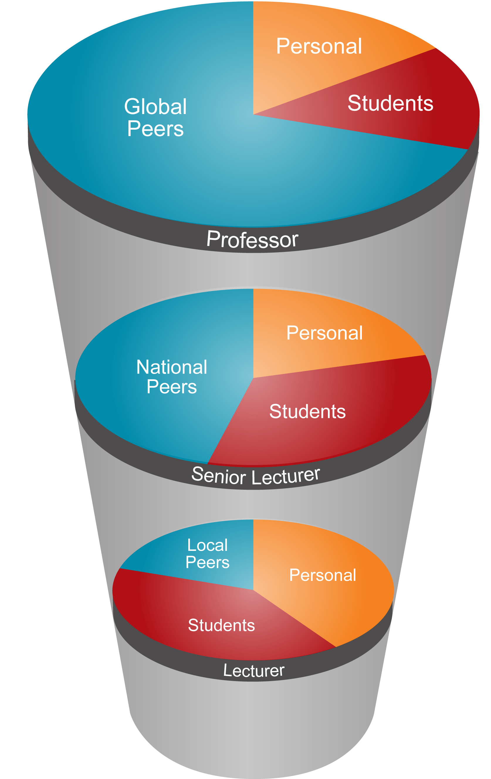

Personal | Evidence of reflective practice, professional development and/or commitment to innovation; evidence of engagement with educational literature or theory, eg how a teaching philosophy/theory informs the applicant’s teaching practice
Students | How students perceive the work of the applicant, through scores in evaluations and qualitative comments; measurements of student achievements in courses the applicant has taught, developed or led, and how student evaluation scores compare with school averages
Peers | Evidence of recognition by colleagues in their institution including Head of School comments, as well as recognition at national or international level. May include peer observations and peer reviews of curriculum development.

Which particular forms of evidence will be expected from each source depends on the promotion policy at each institution. As far as possible, evidence should be verifiable either in documentary form or by peer review.
Figure 4 also illustrates how the three sources of evidence about teaching-related activities – personal, students and peers – may change at different levels of career progression.
Both the proportions of each type of evidence and their impact will vary through a career, for example a lecturer might have more evidence from personal reflection and impact on students, whereas a more senior academic might draw more heavily on evidence of impact on peers.
The mix of evidence provided will also differ for each individual. Each will be uniquely assessed by the promotion committee with regard to an individual’s particular focus, role and/or career profile, and according to the expected level of achievement for a lecturer, senior lecturer or professor.
How is university teaching changing?
University teaching is not a stable, unchanging enterprise. It is a dynamic, fast-moving, multi-faceted profession that is constantly changing to meet new developments and challenges. In recent years, these have included:
- increasing university participation – requiring expertise in developing inclusive curricula to cater for a more diverse student body
- an emphasis on international markets – requiring expertise in intercultural education
- marketisation – requiring an ability to maintain educational values amidst economic pressures
- increased accountability – requiring expertise in quality assurance
- more work-based learning – requiring the ability to manage risk and supervision at a distance
- changing technologies – requiring high-level ICT skills to meet expectations for access across multiple online platforms, particularly among young people
- a more competitive sector including MOOCs (Massive Open Online Courses) and growing enrolments in off-campus provision – requiring sophisticated approaches to online and distance education.
Not only does the nature of the act of teaching change in these conditions; there are also impacts on teaching matters such as curriculum design, assessment, and the type of student outcomes.
These pressures impact on the experience for many university teachers and demand new forms of expertise. As yet, these new forms of expertise are not widely acknowledged in mechanisms for the reward and recognition for teaching. Universities adopting and adapting an evidence framework to underpin reform of teaching in promotion will need to consider if changes in university teaching are adequately reflected.

A framework based on the three perspectives

The Teaching Evidence Framework which follows offers a useful map showing, in practical terms, how these perspectives can produce measurable, credible evidence of teaching to assist both applicants and committees.
Forms and guidelines for promotion based around this framework can encourage academics to present evidence about teaching across a broad scope of teaching activities, from multiple sources including peers, and reflecting multiple spheres of influence.

Promoting Teaching Evidence Framework
A model for universities to enhance understanding of evidence that counts for promotion at various phases of academic career. The examples in the framework are indicative and not necessarily a complete set. This framework is intended to inform an institutional approach, and may not be suitable for use as a guide for applicants. See page 13 for an example guide.
Scope of teaching activity |  | Source of evidence |  |  | Example of evidence | Phase/s of career | Sphere of influence
 |  | Personal | Students | Peers

Professional Learning
University teaching preparation/induction |  |  |  |  | Certificate of completion | Early
Completion of formal qualification in teaching |  |  |  |  | University transcript | Early to mid
Attendances at internal or external teaching-related workshops |  |  |  |  | Institutional records | All
Training and experience from the relevant industry/profession |  |  |  |  | Formal records of professional experience and training | All (if relevant)
Engagement with Professional Standards Framework |  |  |  |  | Peer reviewed teaching portfolio | All

Student Engagement
Statement of teaching philosophy/teaching principles |  |  |  |  | Statement presented | All
Teacher / subject / course evaluations |  |  |  |  | Formal survey reports | All
Student learning outcomes |  |  |  |  | Retention and pass rates; student prizes and projects | All
Peer observations of teaching |  |  |  |  | Formal peer review report or excerpt | All
No of undergraduate and taught postgraduate projects /research degree continuations and/or completions |  |  |  |  | Institutional records; HDR students supervised (successful completions) | Mid onwards
Institutional or national teaching awards |  |  |  |  | Awards that validate nominated areas of expertise | Mid onwards

Curriculum Development
Undergraduate research engagement  10 |  |  |  |  | Documented strategies; student evaluation | All
Reviews of resources developed (including online, media-rich and open resources) |  |  |  |  | Independent reviews | All
Prizes and citations related to resource development |  |  |  |  | Award certificate | Mid to later
Subject/course development, curriculum review |  |  |  |  | Independent reviews | All
Peer evaluations of curriculum |  |  |  |  | Formal review reports | More likely mid to later
Successful introduction and development of major innovations |  |  |  |  | Demonstration; peer review, student evaluations | Any stage but more likely from mid
Development of national or international frameworks, accreditation, standards |  |  |  |  | Membership of advisory panel; peer review of contributions | Mid to later
Textbook |  |  |  |  | Adoption; reviews; sales inc. libraries | Mid to later

Research & Scholarship
Presenter or workshop leader |  |  |  |  | Invitation to present; program and evaluation | All
Statement of scholarship direction |  |  |  |  | Statement presented | All
Application of a scholarly approach |  |  |  |  | Peer review of documented refinements | Early to mid
Peer-reviewed publications |  |  |  |  | Publications; citations | All
Learning and teaching grants |  |  |  |  | Grant application; report | Mid onwards
External referees |  |  |  |  | Reference | All

Leadership & Collaboration
Career development by supervisor/Head/Dean |  |  |  |  | Formal reports | All
Tutor management and cross-campus leadership role in subject or course |  |  |  |  | Independent reports from tutors | Early to mid
Management of cross-campus alignment and consultation |  |  |  |  | Independent reports of action and impact | Mid to later
Leadership feedback |  |  |  |  | Survey results | Mid to later
Mentor roles |  |  |  |  | Independent feedback from mentees; achievements as a result of mentoring | Mid to later
Formal teaching leadership roles |  |  |  |  | Independent reports of contribution or actions | All
Attracting funding to support development or innovation for subject or course |  |  |  |  | Funds awarded; outcomes | All
Service on or chairing of committees / reviews / policy development |  |  |  |  | Committee actions as a result of your input | Mid to later
External leader / reviewer / advisor roles |  |  |  |  | No. of invitations to undertake peer review; outcomes of advisory work | Mid to later
Activities that may involve the collaborative efforts of a team Sphere of influence may extend beyond the university
11
9

Using the Evidence Framework

Mapping using the Evidence Framework helps clarify the spectrum of teaching activity and evidence of teaching at the institution, by:
- articulating the expectations of promotion committees and supervisors, not all of which may be set down in written guidelines
- enhancing transparency in documents and guidelines and in applicant workshops and committee induction
- identifying evidence that can/should be collected and validated centrally for promotion applicants.
Adapting the Evidence Framework may be a preliminary step to a major review of university promotion policies and processes (see accompanying Benchmarking Guide), or a step within a review, or a recommendation arising from a review. However the Framework is used, it is recommended that universities:
- engage the university community in discussion on the nature and scope of teaching in that university’s context.
- consult with the academic community on drafts
- consider if additional evidence might be collected at the institutional level
- provide portfolio tools for evidence collection and analytics tools, for example for citation and impact data
- develop guides to evidence of teaching at each promotion level
- promote the new approach and guides to academics at induction, during staff development , at promotion workshops and on university websites
- use their evidence guides in training of promotion committee members
- establish systems for evaluating the new approach.
There are many ways a guide or resource could be presented, depending on the unique approach of each university. See next page for a sample guide which highlights the relationship between sources of evidence and level of career progression for one university’s context.
For each promotion level, it gives examples of evidence which could be used to substantiate a case for promotion. For promotion to higher levels, a wider and more significant impact should be demonstrated.
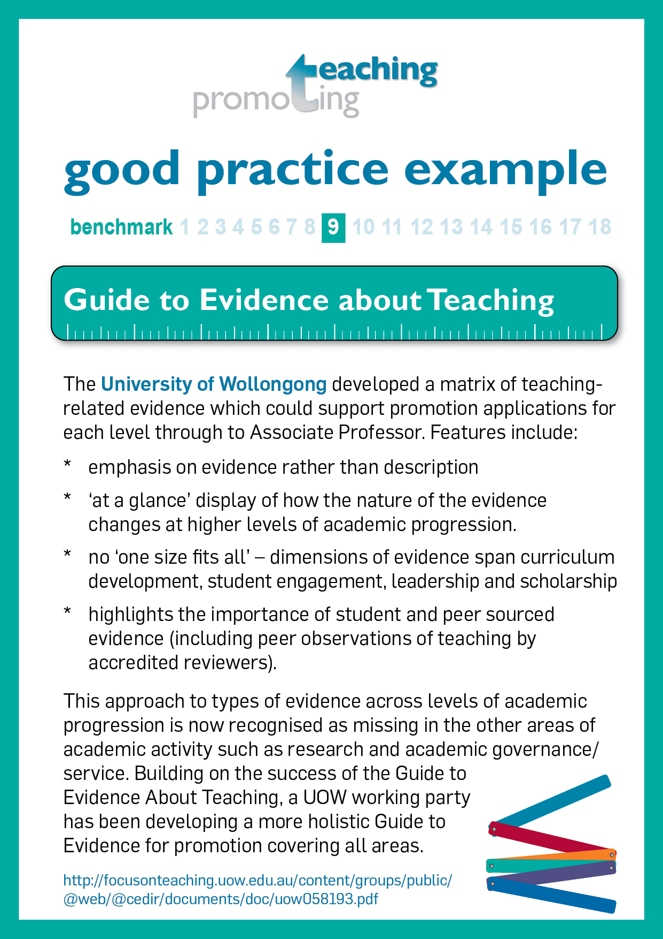

Good practice examples
were invited throughout the project. This good practice example from the University of Wollongong describes the foundational work which was the original inspiration for the Making Evidence Count framework. For more good practice examples, see Promoting Teaching: Benchmarking Guide

The Framework in Action: sample guide
 | Senior Lecturer | Reader/Associate Professor & Professor
 | Include evidence in your application from the following list of examples, choosing those relevant to your context and outlining how they demonstrate innovation, excellence and impact:
 | Engagement with staff development activities  Evidence of reflective approach to teaching  Integration of scholarship and research with teaching  Courses attended and professional development undertaken  Self-assessment of teaching performance  Awareness of relevant quality assurance frameworks and benchmarks  Engagement with professional standards framework eg HEA Senior Fellowship  Membership of relevant professional bodies  Institutional teaching award | Engagement with professional standards framework eg HEA Principal Fellowship  National teaching awards  External prizes
 | Excellent student feedback from course and module questionnaires and other sources  Feedback from student experience surveys  Student achievement and progression  Student recruitment to courses or modules  Student retention on courses or modules  Production of teaching materials (eg Blackboard materials, learning packages)  Successful outcome of supervision of UG or PG research projects / PG research students | Sustained excellent student feedback from course and module questionnaires and other sources  Leadership of successful initiatives to improve outcomes of student experience surveys  Leadership of successful initiatives to improve student achievement and retention  Leadership of successful initiatives to improve student recruitment  Improved cohort achievement  Leadership of student employability initiatives  Successful outcome of supervision of UG or PG research projects / PG research students
 | PI or Co-I on grants for pedagogic research  Appointment as a course coordinator  Accreditation of courses by professional bodies  Departmental leadership in teaching  Membership of Departmental Learning and Teaching Committee  Publications, presentation or workshops on teaching  Internal module or subject evaluations  Contributions to textbooks  Referee for journals in the area of teaching  Reviewer of pedagogic grant proposals  Prizes and citations for courseware  Providing mentorship to colleagues  External examiner comments  Peer supported evidence of involvement in faculty/university level initiatives (eg policy, staff development etc) | PI or Co-I on major grants for pedagogic research  Chair of faculty or university committees  External examiner for taught courses  QAA reviewer  Offices of responsibility in relevant professional bodies  Significant record of publications, presentation or workshops on teaching  Invited reviewer/assessor of teaching at comparable institutions (eg for program approval, periodic review)  Authorship/editorship of textbooks  Editorship and membership of journal boards or referee for journals in the area of teaching  National or international reputation as evidenced by invitations to speak at conferences  Successful mentorship, peer reviewer, chair of faculty/university committees  Peer supported evidence of leadership at faculty/ university level initiatives (eg policy, staff development etc)  Other National / international impact (eg funding body panel member, advisor, consultant, editor)  Outcomes of cross-university collaborations

Impact on peers
Impact on students
Personal

Principles for putting the framework into practice
For the Teaching Evidence Framework to inform improvement of university policy and practice, four Principles are proposed. These principles relate to the Promoting Teaching: Good Practice Benchmarks.

Principle 1: Alignment
The university aligns its promotion policies, promotion application forms, recruitment processes, career development proformas, performance expectation frameworks and teaching grants/awards, by basing them all on a published university definition of teaching and university guide to evidence about teaching (Benchmarks 6 & 7).

Principle 2: Flexibility
Forms and guidelines for promotion recognise that each academic teaching profile is unique. There is no assumption that an academic will be active in every area of activity or that “one size fits all” (Benchmark 9).

Principle 3: Systems
The university offers systems to collect and validate an array of data and evidence about teaching, both to support promotion applicants and to provide meaningful institutional analytics for promotion committees and university strategic planning (Benchmark 10).

Principle 4: Training
The university provides regular, mandatory induction and training for promotion committee members, academic supervisors and applicants on how to demonstrate and evaluate individual teaching achievements (Benchmark 12).

Summary of Good Practice Benchmarks
(for full version, see Promoting Teaching: Good Practice Benchmarks on www.promotingteaching.com)

Plans & policies
1. University plans
2. Promotion policies

Promotion applications
8. Forms and guidelines
9. Evidence
10. Systems

Perceptions & practices
3. University leaders
4. Leaders of academic units
5. Peers

Promotion committee
11. Membership
12. Preparation
13. Procedures
14. External input
15. Transparency

Promotion applicants
6. Career planning and advice
7. Academic mentors and supervisors

Outcomes & review
16. Equitable outcomes
17. Review cycle
18. Positive perception

Academic staff perceive that teachingachievements are valued in promotion processes

.

Evidence Cards
can be used in promotion workshops for prompting discussion about evidence of teaching excellence: see Promoting Teaching: Benchmarking Guide

How does the Evidence Framework relate to Performance Expectations Frameworks?
Many institutions have a performance expectation framework (PEF) for each academic level. These expectations often map onto a professional standards framework (PSF).
While PEFs and PSFs are related to performance, they are different from criteria for promotion. PEFs and PSFs set a minimum standard, but in applications for promotion, committees are looking for excellence beyond what is normally expected at that level. Several types of evidence when considered holistically might demonstrate that an individual is performing at a high level, suggesting their potential for a role above their current level of activity.
Typically, successful applicants are able to demonstrate through evidence that they are already having an impact at the level for which they are applying and, if applying for Chair/Reader, sustained impact. Many applicants are also innovating or contributing in ways not anticipated in the PEFs and PSFs for their role.
PEF and PSF documents are relevant to evaluating aspects of applications as they clarify role expectations. However, they are unsuitable for evaluating overall teaching excellence or for underpinning promotion criteria. They may:
- be instrumental, for example be overly-focused on a narrow range of outcomes
- fail to give sufficient attention to leadership of teaching
- not acknowledge the depth and breadth of teaching expertise
- not take account of deep knowledge of teaching and learning processes in higher education
- not address the changing higher education climate in which teaching academics operate
- not reflect changes to an academic’s role which occurred after a PEF or PSF was finalised.

Evaluating teaching evidence

By clarifying the sources and range of evidence about teaching, universities can provide guidance to applicants and committees.
This does not in any way suggest that “ticking boxes” is a pathway to promotion, whether for teaching or for any other area of achievement. Rather, the framework seeks to clarify the nature of teaching and the evidence relevant to teaching achievement.
Is peer review of teaching credible as evidence for promotion?
Evidence about teaching should not be solely dependent on student feedback and, in fact, is as reliant on peer review as is evidence about research. However, although most universities encourage informal peer review (Harris et al, 2008), most do not have processes for peer review of teaching that can be used for promotion evidence.
Peer review for promotion needs to be credible and verifiable (Crisp et al 2009). The principles of choice, credibility and confidentiality are useful in implementing a peer review process for promotion purposes.

Credibility
- peer reviewers are invited from the pool of academics in a university who have won university or national peer reviewed teaching grants or teaching awards
- peer reviewers are trained; and the training involves undergoing peer review
- for promotion one reviewer must be external to the reviewee’s discipline
- use of reviewers external to the university should be considered

Choice
- process is optional and an academic can withdraw at any time
- list of esteemed peer reviewers is on the website so that reviewees can select their own reviewer
- choice of review proformas or review criteria
- choice of peer observation of teaching or peer review of educational practice, distinguishing between classroom practice and the broader activities such as curriculum development and leadership

Confidentiality
- completed reviews, signed by reviewer and reviewee, are stored confidentially by central service for release to promotions committee if applicant chooses.
As with any other area of academic achievement, promotion committees will still need to look at evaluating that evidence for demonstration of excellence, quality, innovation and impact.
And as with other areas of academic achievement, evidence of teaching should as far as possible be underpinned by peer review, for example:
- peer observation of teaching by accredited reviewers and/or head of school or discipline area
- peer review of curriculum by esteemed external reviewer
- scholarly articles published in peer-reviewed journals
- for major teaching projects and reviews, peer agreement as to the relative contributions of team members
- teaching portfolio evaluated by independent, accredited reviewer

Conclusion: making evidence count

Making Evidence Count enables university promotion committees to better recognise teaching achievement in promotion applications. Understanding how teaching can be “measured” is a cornerstone of the Good Practice Benchmarks.
Where such a framework has been implemented, it has been welcomed by both applicants and committee members. Applicants saw clear guidance to assist in planning for promotion and writing applications, as well as greater recognition of their achievements. Committee members appreciated the clarity around how teaching should be evidenced and evaluated.
In fact, the project partners discovered that evidencing teaching reveals misconceptions in evidencing other areas of academic activity such as research and service. Therefore, the Promoting Teaching framework can be the starting point for universities to build a more holistic framework covering all areas of academic activity including research and leadership or governance.
The Promoting Teaching team welcomes feedback on the model and invites universities to find benchmarking partners via our website. Please also use the website to submit Good Practice Examples to add to the higher education sector’s growing understanding of reward and recognition of teaching.

What do we mean by professional learning?
All professions provide foundation training and continuing education for their members. The profession of university teaching is no exception. A professional is in part defined by their ongoing commitment to engaging with the body of knowledge of their profession.
In response to the complex challenges now faced by teaching academics (see p 4), a new paradigm has emerged based on professionalism of learning and teaching expertise in higher education (Light, 2000).
Professional learning is often associated with attending workshops and events. Northcott (2011) however notes that shorter, top-down, agenda-led events do not tend to lead to demonstrable changes, whereas practice-based or longer, more comprehensive degree and diploma courses do appear to effect positive change.
The notion of the reflective professional has also gained increasing attention. This promotes not only teaching skills but also the values and conceptual framework that enable academics to design, lead, manage and deliver high quality student learning experiences. Knight, Tait and Yorke (2006) stress the significance of non‐formal learning as an important part of a commitment to developing as professional teacher, eg:
- learning by doing the job, through active and critical reflection on present and past experiences and teaching performance
- engaging with students and their feedback (formal and informal)
- learning through conversation with others.
Evidence of professional learning therefore might include a range of evidence, from workshop attendances and course completions to reflective statements describing how professional learning and reflection have been applied to enhance the student experience.

References and readings

Adult education
Knowles, M S (1980) The Modern Practice of Adult Education: From Pedagogy to Andragogy. Englewood Cliffs (NJ): Cambridge Adult Education.
Shulman, L S (1987) Knowledge and Teaching: Foundations of the New Reform. Harvard Educational Review, vol 57 no 1, pp 1-22.

Curriculum development
Biggs, J (1996) Enhancing Teaching through Constructive Alignment. Higher Education, vol 32, pp 347-364.
Hicks, O (2007), Curriculum in Higher Education in Australia – Hello?, in Enhancing Higher Education, Theory and Scholarship, Proceedings of the 30th HERDSA Annual Conference, Adelaide, 8-11 July.
Middlehurst, R (2007) Innovation in Higher Education: Implications for the Future in White, S C and Glickman, T S (eds) Managing for Innovation: New Directions for Higher Education no 137, Wiley.
Drew, G M (2010) Issues and Challenges in Higher Education Leadership: Engaging for Change. Australian Educational Researcher, vol 37 no 3, pp 57-76.
Kuh, G D (2013) Promise in Action: Examples of Institutional Success. New Directions for Higher Education no 16, Wiley.
Open University Centre for Studies in Higher Education Practice, Bridging the Gap: Briefing Paper no 8: Innovation and Creativity in the Curriculum www.innovations.ac.uk/btg/resources/publications/innovation.pdf

Evidence of university teaching practice
Higher Education Academy (2011) UK Professional Standards Framework for Teaching and Supporting Learning in Higher Education. www.heacademy.ac.uk/ assets/documents/ukpsf/ukpsf.pdf
Higher Education Academy (2013), National Teaching Fellowship Scheme, www.heacademy.ac.uk/ntfs
Office for Learning and Teaching (2012) Australian Awards for University Teaching. Canberra: Commonwealth Government. Available from www.olt.gov.au/awards/program-awards/
Olsson, T and Roxå, T (2013) Assessing and Rewarding Excellent Academic Teachers for the Benefit of an Organization. European Journal of Higher Education, vol 3 no 1, pp 40-61.
Smith, C D (2008) Building Effectiveness in Teaching through Targeted Evaluation and Response: Connecting Evaluation to Teaching Improvement in Higher Education. Assessment & Evaluation in Higher Education, vol 33 no 5, pp 517-533.
Wills, S, Brown C (2009) Academic Promotion: A Guide to Evidence About Teaching. University of Wollongong. focusonteaching.uow.edu.au/content/groups/public/@web/@cedir/documents/doc/uow058193.pdf

Leadership
Gibbs, G (2012) The Implications of ‘Dimension of Quality’ in a Market Environment. York: Higher Education Academy.
Jones, S, Applebee, A, Harvey, M and Lefoe, G E (2010) Scoping a Distributed Leadership Matrix for Higher Education, in Devlin, M, Nagy, J and Lichtenberg, A (eds), Proceedings of Reshaping Higher Education: 33rd Higher Education Research and Development Society of Australasia. Sydney: HERDSA, pp 359-369.
Rickinson, M, Spencer, R and Stainton, C (2012) NTFS Review: Report on Findings. York: Higher Education Academy.
Skelton, A (2004) Understanding Teaching Excellence in Higher Education: a Critical Evaluation of the National Teaching Fellowship Scheme. Studies in Higher Education, vol 29 no 4, pp 451-468.

Peer review
Crisp, G, Sadler, R, Krause, K, Buckridge, M, Wills, S, Brown, C, McLean, J, Dalton, H, Le Lievre, K, Brougham, B (2009) Peer Review of Teaching for Promotion Purposes: a Project to Develop and Implement a Pilot Program of External Peer Review of Teaching in Four Australian Universities. Sydney: ALTC. http://www.altc.edu.au/resource-peer-review-teaching-adelaide-2009
Gosling, D and Mason O’Connor, K (eds) (2009) Beyond the Peer Observation of Teaching. SEDA Paper 124. London: Staff and Educational Development Association.
Harris, K, Farrell, K, Bell, M, Devlin, M, James R (2008) Peer Review of Teaching in Australian Higher Education: A Handbook to Support Institutions in Developing and Embedding Effective Policies and Practices, Melbourne and Wollongong: University of Melbourne and University of Wollongong.
McKenzie, J and Parker, N (2011) Final Report: Peer Review in Online and Blended Learning Environments. Canberra: ALTC.

Professional learning
Debowski, S (2012) The New Academic: A Strategic Handbook, McGraw Hill Open University Press.
Knight, P, Tait, J and Yorke, M (2006) The Professional Learning of Teachers in Higher Education. Studies in Higher Education, vol 31 no 3, pp 319-339.
Light, G, Calkins, S and Cox, R (2009) Learning and Teaching in Higher Education: The Reflective Professional. London, Sage Publications Ltd.
Northcott, J (2010) ‘Years after the Course’: Dialogues with Mid-career Practitioners about the Resilience of Professional Learning from a Higher Education CPD Programme. Enhancing the Learner Experience in Higher Education, vol 2 no 1, pp 41-55.

Scholarship
Andresen, L W (2000) A Useable, Trans-disciplinary Conception of Scholarship. Higher Education Research and Development, vol 19, pp 137–153.
Boyer, E (1990) Scholarship Reconsidered: Priorities of the Professoriate, Carnegie Foundation for the Advancement of Teaching. Available from https://depts.washington.edu/ gs630/Spring/Boyer.pdf

Healey, M (2000) Developing the Scholarship of Teaching through the Disciplines, Higher Education Research and Development, vol 19 no 2, pp 169-189.
Kreber, C (2002) Teaching Excellence, Teaching Expertise, and the Scholarship of Teaching. Innovative Higher Education. September 2002, vol 27 no 1, pp 5-23.
Sample, M (2013), When Does Service Become Scholarship? Sample Reality, 8 February 2013 http://www.samplereality.com/2013/02/08/when-does-service-become-scholarship/

Student engagement
Hay, I (ed) (2011) Inspiring Academics: Learning with the World’s Great University Teachers, McGraw Hill/Open University Press.
Hunt, L and Chalmers, D (eds) (2012) University Teaching in Focus - A Learning-centred Approach, Oxford: Routledge.
Skelton, A (ed) (2007) International Perspective on Teaching Excellence in Higher Education: Improving Knowledge and Practice. London: Routledge.

Acknowledgments
Making Evidence Count (2013) was produced by the Promoting Teaching Project and funded by the UK Higher Education Academy.
Core Project Team
Prof Sandra Wills (AUS Project Leader) & A/Prof Christine Brown | University of Wollongong
Prof Annette Cashmore (UK Project Leader) & Dr Chris Cane | University of Leicester
Prof David Sadler & Dr Sara Booth (Project Coordinator) | University of Tasmania
Prof Stephen McHanwell & Dr Sue Robson | Newcastle University
Project Officers
Anne Melano & Jan Sullivan (Wollongong), Craig Bartle (Leicester), Dr Cassandra Saunders (Tasmania), Dr Elaine Hall (Newcastle)
Special Contributing Author
A/Prof Rosemary Callingham (Tasmania) was the author of many sections on the nature of university teaching in this framework.
Graphics
Adam Orvad (Wollongong)

www.promotingteaching.com

