template #6
diamond ranking activities for promotion workshops

Purpose
Diamond ranking (see Clark, 2012, for a full discussion) is a tool drawn from thinking skills pedagogies which is designed to explore participants’ sense of hierarchy in relation to a set of ideas or images. Participants are provided with a number of cards containing statements or ideas and asked to arrange them in a diamond formation (see Figure 1). The criteria for sorting are not rigidly fixed but descriptors that are frequently used include important, interesting, better or significant. One of these criteria is then used to rank the most “interesting”, “important” statement at the top, the next most interesting in an equal position in the second row and so on until the last statement, the least “interesting” or “important” is placed at the bottom.

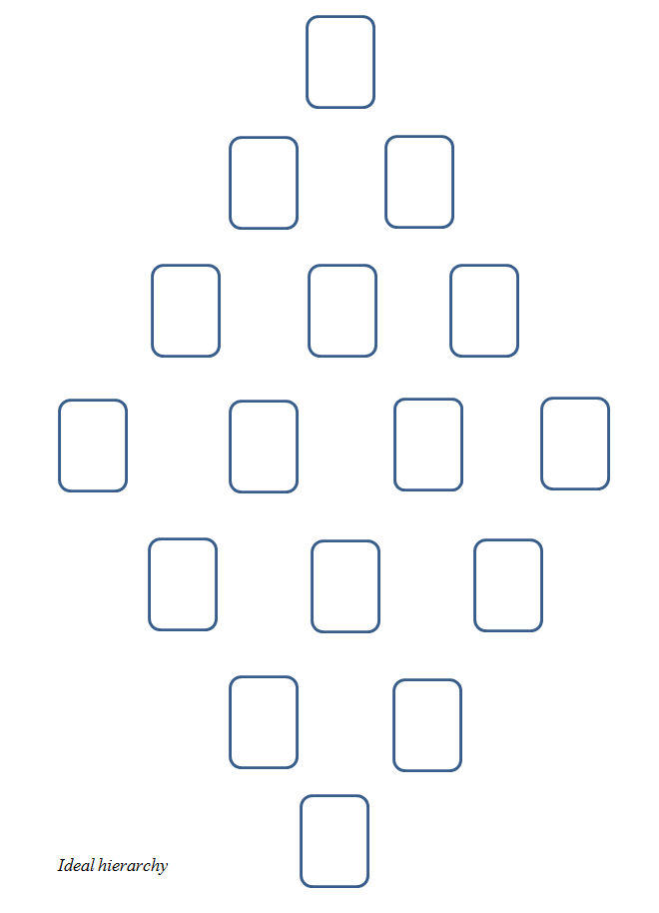 | 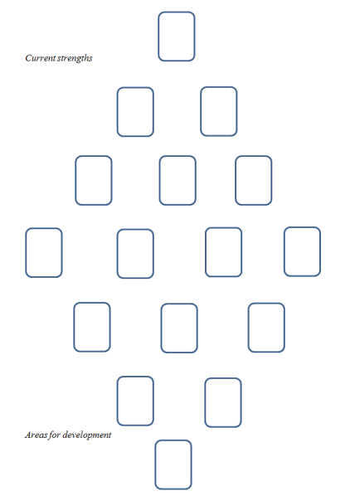 | 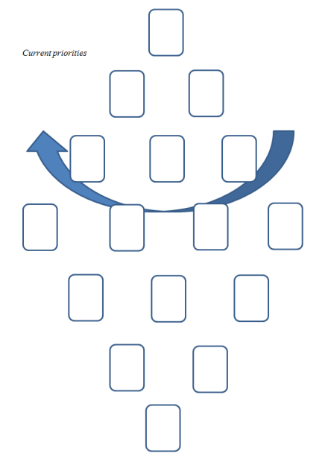

Figure 1: Diamond ranking sheets for discussion of the Promoting Teaching set of Good Practice Examples

As a discussion tool, this diamond as an ‘end product’ enables participants to crystallise their priorities and can scaffold action planning, whilst as a research tool, the placement lends itself to quantitative analysis. It is typically a collaborative activity, as the discussions about where to place elements and why are as important to elucidating the thinking as the final diamond, meaning that the complexity of action planning can be addressed as well as providing qualitative analysis opportunities. One of the cards is usually blank, or an extra blank card is provided so that participants can introduce their own ideas.

Ranking the Good Practice Examples
Two sets of cards are provided as exercises to facilitate discussion about promotion for teaching: Good Practice Examples and Evidence Cards. Template #7 provides double-sided sheets of these cards to run through your photocopier or send to a printing company. Guillotine the sheets in order to make up extra sets of cards for the activity, one set per group.

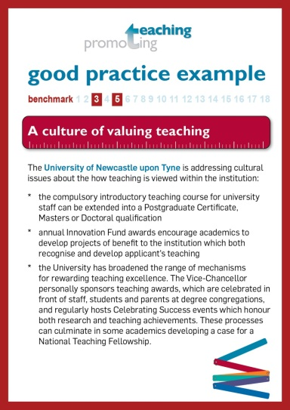 |  | 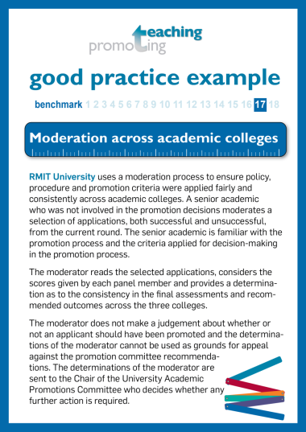
Fifteen Good Practice Example cards can be used to stimulate discussion around institutional priorities. Provide a sixteenth blank card so that participants can write an example from their own university.

Ranking the Evidence Cards
A second set of ten cards is included in this pack, each card describing an example of evidence of achievement in teaching drawn from Promoting Teaching’s Evidence Framework: Making Teaching Count. These can be used by a workshop facilitator to stimulate discussion about the nature of evidence in teaching. The facilitator would need to prepare a diamond sheet with 10 empty spaces.

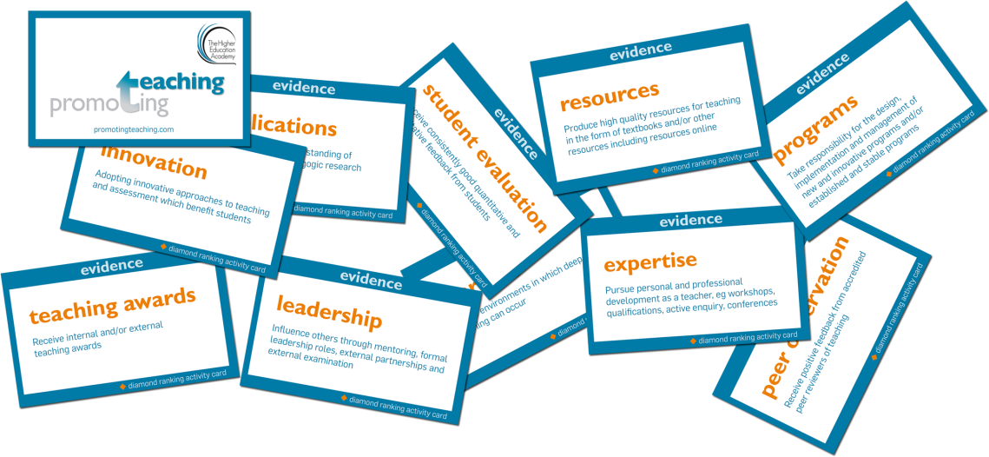

Clark, J. (2012) Using diamond ranking as visual cues to engage young people in the research process. Qualitative Research Journal 12(2), 222-2

